**Project Documentation**

**CookBook – Your Virtual Kitchen Assistant**

# 1. Introduction

Project Title: CookBook – Your Virtual Kitchen Assistant

Team ID: NM2025TMID36510

Team Size: 4

Team Leader: Mercy Cuety T 24csmercycuety056@gmail.com

Team Members:

-Monika M 24csmonikam057@gmail.com

-Sineha C 24cssinehac093@gmail.com

-Shabana Parveen M 24csshabana092@gmail.com

# 2. Project Overview

Purpose: CookBook provides free and accessible culinary knowledge, encourages healthy eating, and connects food lovers worldwide.

Key Features:

- Recipe search & browsing

- Save favorite recipes

- Community recipe sharing

- Premium: Meal planning & nutrition analysis

- Admin control panel

- In-app purchases & affiliate links

# 3. Architecture

Frontend: React.js, HTML, CSS, JavaScript (Bootstrap/Material UI)

Backend: Node.js with Express.js

Database: MongoDB

# 4. Setup Instructions

Prerequisites: Node.js, MongoDB, Git, React.js, Express.js, Mongoose, VS Code

Installation Steps:

git clone <repo_url>  
cd client  
npm install  
cd ../server  
npm install

# 5. Folder Structure

CookBook/  
 ├── client/ # React frontend  
 │ ├── components/  
 │ └── pages/  
 └── server/ # Node.js backend  
 ├── routes/  
 ├── models/  
 └── controllers/

# 6. Running the Application

Frontend:  
cd client  
npm start  
  
Backend:  
cd server  
npm start  
  
Access: http://localhost:3000

# 7. API Documentation

User:  
- /api/user/register  
- /api/user/login  
  
Recipes:  
- /api/recipes/search?query=  
- /api/recipes/add  
  
Meal Plans:  
- /api/mealplan/create  
  
Favorites:  
- /api/favorites/add  
- /api/favorites/:userId

# 8. Authentication

JWT-based authentication  
Middleware protects private routes

# 9. User Interface

- Landing Page

- User Dashboard

- Recipe Details Page

- Admin Panel

# 10. Use Cases

As a user, I can search recipes by name or ingredient.

As a user, I can save my favorite recipes for later.

As a premium user, I can generate a nutrition-based meal plan.

As an admin, I can manage user accounts and recipes.

# 11. Testing

| Feature | Expected Output | Status |
| --- | --- | --- |
| User Registration | Account created successfully | ✅ Passed |
| Login | User logs in securely | ✅ Passed |
| Recipe Search | Recipes appear for given keyword | ✅ Passed |
| Save Favorite | Recipe saved in user dashboard | ✅ Passed |
| Meal Plan | Plan created with recipes | ⚠️ In Progress |

# 12. Screenshots / Demo:

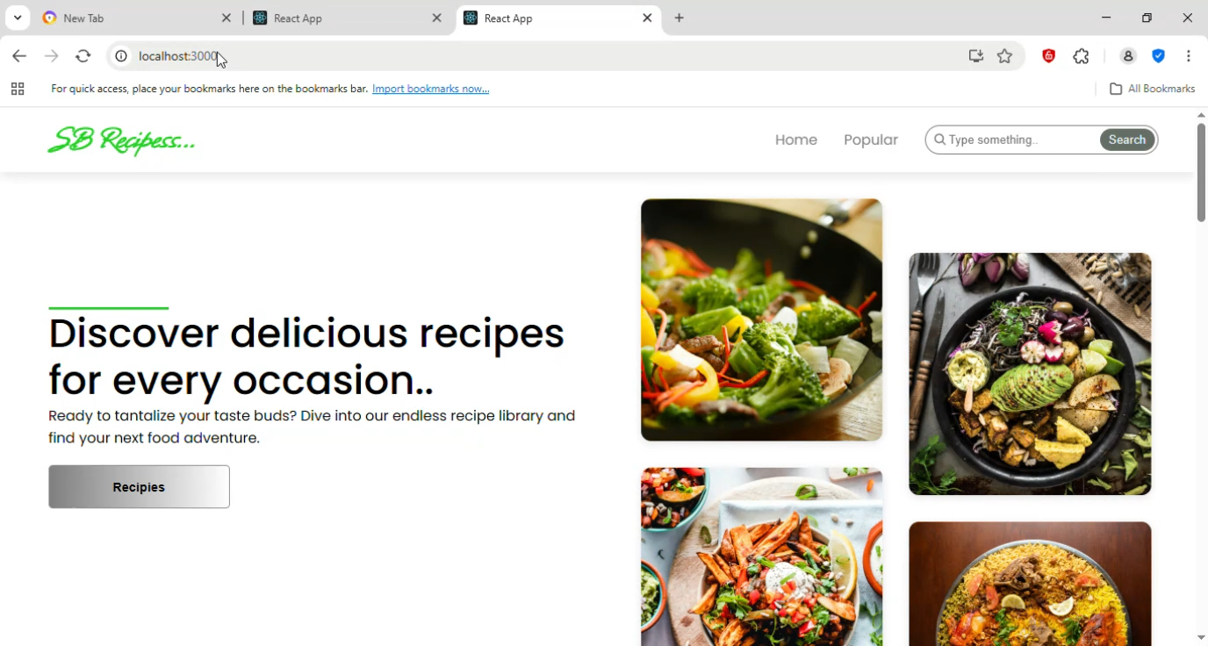

# 13. Known Issues

- Limited recipe dataset initially

- Mobile UI needs improvement

- Some features still in development (Meal plan)

# 14. Future Enhancements

- AI-based personalized recipe suggestions

- Voice-assisted cooking mode

- Grocery shopping integration

- Social features: likes, comments, shares